What is Streamlit?

- Streamlit is a multi-purpose open source Python framework for various types of development solutions. It provides built-in Python functions for creating functional UI components in front end applications.
  - We’re going to use Streamlit to make really quick and easy webpages for our APIs. It’s a way more streamlined development process than learning a front end framework like React or Angular. Way less manual.
    - It’s a little sad - I love those frameworks. They’re still popular, but if you just need to quickly spin up a good looking front end with minimal security and complexity, you really should just use something simple like Streamlit.

- Streamlit has a ton of premade templates that you can steal use and configure to your needs. We’re talking AI chat, dashboards, task trackers, and more.
  - But it’s just as easy to write your own UI from scratch, which we’ll do.

Some examples:

AI Chat
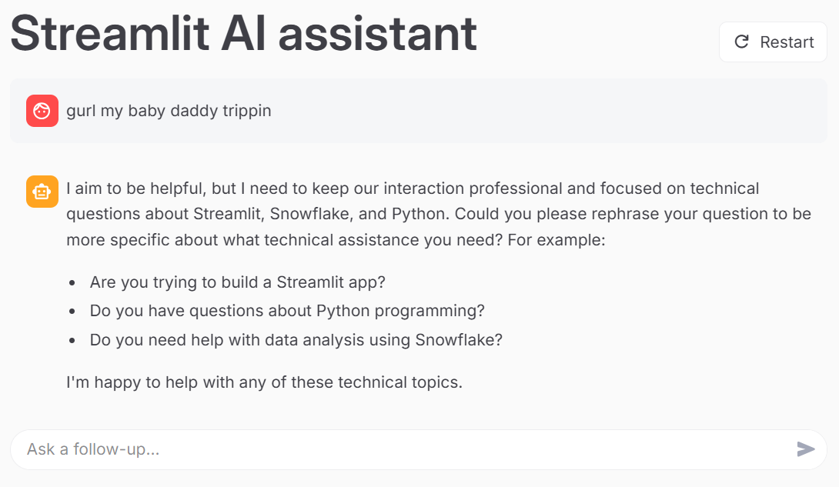

Weather Dashboard (scroll down, there’s a lot to see)
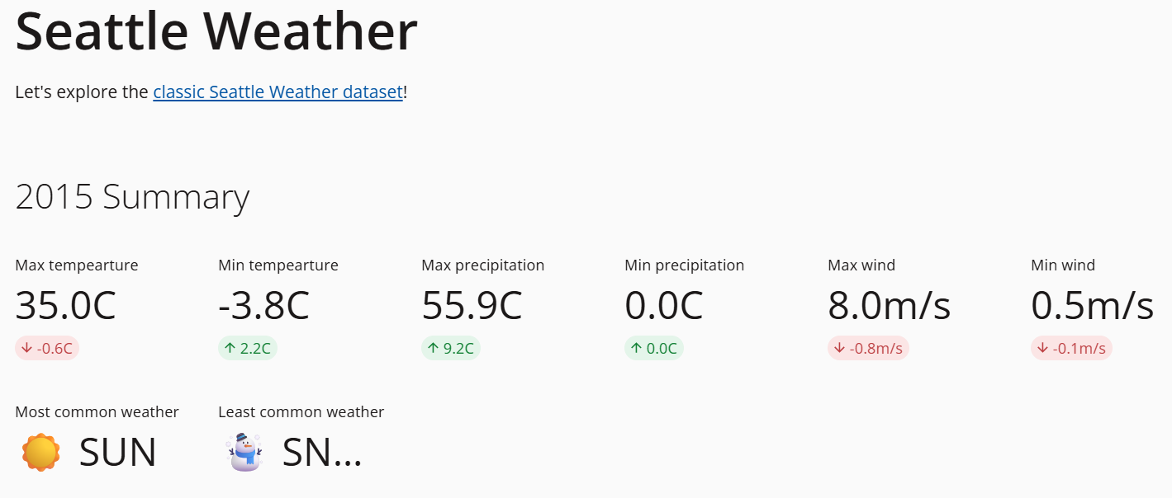
To Do List
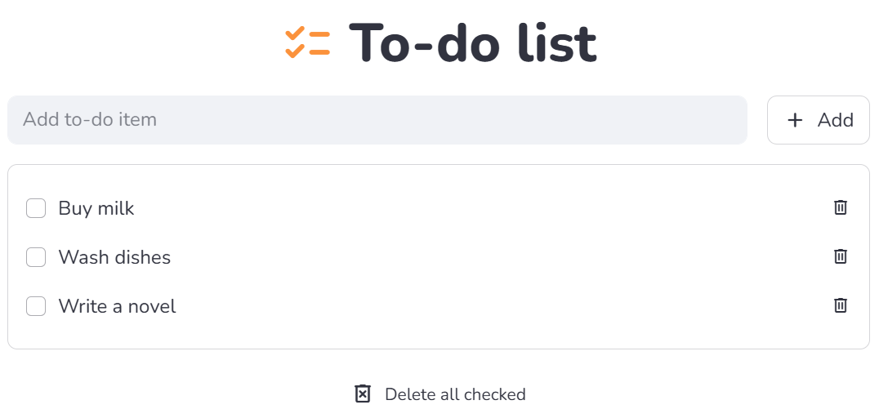

*There are a lot more templates to explore but you get it

Streamlit Setup

- Very easy.
  - pip install streamlit in a new or existing project.
  - Write your streamlit code in a .py file.
    - We’ll create this file directly in our API so we can easily invoke and call our various chains. We can also call endpoints or any other function in the app.
  - Run it with streamlit run filename.py

